**FAUCLTY PROFILE**

|  |
| --- |
| HINDI |

DEPARTMENT:

|  |
| --- |
| DR. PARWATI KACHHAP |

Name:

DIGITAL PHOTOGRAPH

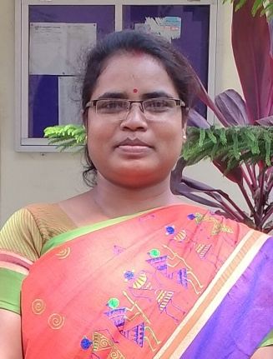

|  |  |
| --- | --- |
| DESIGNATION | Assistant Professor and Head of the Department |
| DATE OF JOININIG THIS COLLEGE | 06.03.2008 |
| TEACHING EXPERIENCE [at UG & PG level only]: | 12 Years 7 months |
| CONTACT NO.: | 9939109071 |
| EMAIL ID: | Kaparwati.scc@gmail.com |
| ACADEMIC QUALIFICATION [PG & above only]: | M.A, Ph.D, JET, NET |
| SPECIALZIATION/RESEARCH AREA: | fof'’V fo|k ,ao jpukdkj@vkpk;Z jkepUnª 'kqDy dh dkO; /kkj.kk vkSj mudh dforkvksa dk ewY;kadu |
| SUPERVISING RESEARCH SCHOLARS/ PURSUING  RESEARCH: | NA. |

|  |  |
| --- | --- |
| REASEACH PAPERS/ ARTICLES: | 1- 'kqDy th dh dforkvksa esa O;Dr ekuoh; laosnuk (ANUSILANA Research Journal of India, Cultural, Social & Philosophical Stream 2010) ISSN0973-8762  2- jkepUnª dh Hkk’kk lajpuk & nqf’Vikr vad& 70 twu 2011] i`0 12&14 ISSN2231-3079  3- vkpk;Z 'kqDy dk izd`fr izse& lkfgR; vkaxu Vol-I, Issue- II July , Page No- 153&154 ISSN-23944889  4- vkpk;Z jkepUnª 'kqDy th dh dforkvksa esa ns”k izse INWARD EYE Vol-I, No- 2 Dec (57-61) ISSN-2456-019X |
| EDITED/ AUTHORED BOOKS: | NIL |
| AFFLIATION/ ASSOCIATION WITH JOURNALS  etc.: | NIL |
| MEMBERSHIP/ATTACHMENT WITH DIFFERENT ASSOCIATION/INSTITUTIONS/BODIES/BOARD: | JSR EDITORS ISSN 2349-9710, Vol. 5 No. 3  July Sep2018  The Intellectual Voice , ISSN No- 2581-432X  INWARD EYE ISSN No.- 2456-019X  VISHWA- International Hindi Association ISSN No. 25721550  ST, SC cell member  Anti Ragging cell member  Women cell member |
| ACHIEVMENTS/FELICITATIONS/AWARDS RECEIVED: | Dr. Ambedkar Fellowship  National Award - 2018 |
| ANY OTHER RELEVANT INFORMATION: | fofHkUu fo”ofo|ky;ksa }kjk vk;ksftr jk’Vªh; ,ao varjk’Vªh; osfoukj esa lgHkkfxrkA |

